Are you Un-Protected?

If you have assets, or savings. If you are concerned about finances for your parents or children. If you are thinking about retirement. If you have a small business. If you are concerned about value of the dollar or real estate values. If you are aware that anyone can steal your identity or show up unannounced at your home....

Solutions are explained that can provide privacy, and protect your family from financial attack. You can almost completely eliminate losses from medical bills, lawsuits, real estate losses, identity theft, and mistakes of your relatives. Sometimes there are tax savings too.

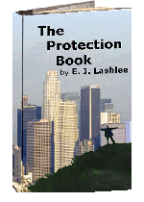
Learn how to Privately own
and Privately protect….
….your home
….your business
….your bank accounts
….your stock
….your retirement
….your vehicles
….your collectables
You can recover your privacy and protect your family.

For ourselves, our staff, our families, and our friends.

Email at truetrust@gmail.com or
Phone: (949) 497-3600 / (10am to 10pm – 7 days a week)

Read some of the book at: www.TheProtectionBook.com

