House for Sale
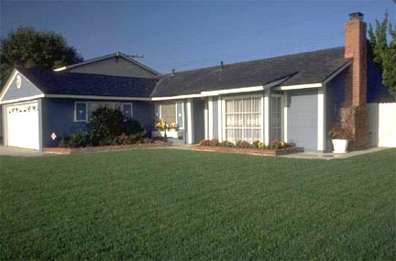
123 Brock Street
Bellevue, WA 60522
Call Terry Adams – (864) 555-0123
Features and Facts
Built in 1991
.47 acre lot
Brick foundation
Vaulted ceiling
Open dining area
Ample closet space
Floored attic for storage
Atrium doors to deck
Tiled fireplace
Wood pile
Aluminum gutters
Fiberglass shingles
Central heating
Dishwasher and range
Double pane windows
Municipal water/sewer

Convenient washer/dryer
Energy-efficient electric water heater
Deadbolts on all entrances
Large master bedroom suite
Ceiling fans in all rooms
Built-in microwave
Disposal unit
Attached garage with door opener
Shelves in garage
Quiet street
Private backyard
Separate dining room
3 bedrooms
Room Sizes
Family room - 16’3” x 16’1”
Dining room - 12’ x 9’6”
Kitchen - 9’9” x 9’5”
Master bedroom - 12’1” x 11’11”
Bedroom - 12’1” x 11’11”
Bedroom - 11’11” x 11’11”
Total = 1293 sq. feet
Schools
School of Fine Art
Graphic Design Institute
Costs
Asking price: $226,500
Property taxes: $1,811
Utilities: $150/month

Floor plan
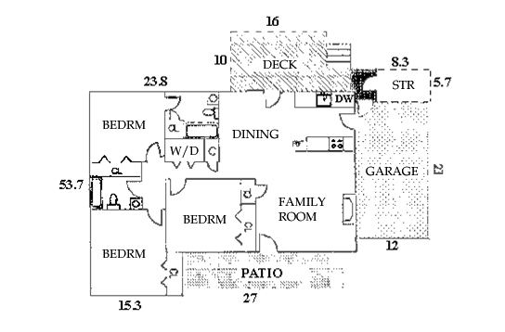

Location Map

